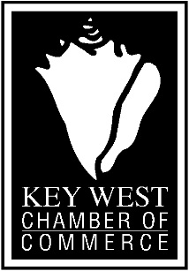
510 GREENE STREET, KEY WEST, FL 33040 ·305-294-2587·WWW.KEYWESTCHAMBER.ORG

FOR IMMEDIATE RELEASE
September 4, 2015
Contact: Virginia Panico, 305-294-2587
Vpanico@keywestchamber.org

Key West Chamber to Award Prizes for Local Floats

The Key West Chamber of Commerce is announcing an award program and prizes for local float entries into the annual parade that culminates the events at the end of October each year. The new program will reward the best overall local float participant of the parade $7,500, with the runner up local float awarded $2,500. In addition, the Chamber will be sponsoring a “Championship Trophy” to the winner of the float contest which it intends to pass on from year to year to the next overall winner. “Think of this as the “Stanley Cup Trophy” of the parade said Nicki Will, President of the Key West Chamber of Commerce. “The goal is to initiate some healthy competition with financial rewards, and bring some passion back to the parade”. “We hope to see hotels, guesthouses, restaurants, bars and retailers putting in the time and effort to be able to hoist the “cup”.

The Chamber has closely followed the recent concerns about the parade and a perception of dwindling local participation. The new program will have eligibility requirements where only local participants qualify for the contest award and will have decency standards. “While we cannot eliminate all concerns about the conduct of people attending the event, we believe we can provide incentive to improve the parade itself which could lead to increased local participation and pride in the city’s signature and most recognized event.” said Will. The Chamber Board is also in talks with local businesses and property owners to create a staging area in Key West for floats to be assembled.

For more information about participating in the Chamber’s contest please contact the Key West Chamber of Commerce office at 305-294-2587.
“The mission of the Greater Key West Chamber of Commerce is to serve its members
and maintain and promote a viable economy for the businesses and working people of Key West.”

